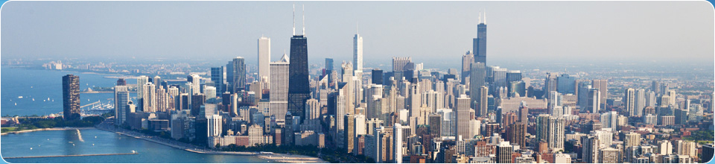

**Guidelines**

The final project is an individual initiative designed to synthesize all of the concepts and principles learned during the semester and to give you more hands on experience with enterprise computing.

**Business Problem**

The City of Chicago has contracted you to build a system that will help city planners better explain how crime has affected the behavior of the city’s residents, businesses and their police department. Some of the uses of your new system may include:

* Assisting the Chicago Police Department to better deploy its resources so that the police department can be more proactive in preventing future crime
* Helping the public better understand crime in their respective neighborhoods
* Supporting neighborhood watch groups
* Supporting police oversight groups
* Helping tourists avoid more dangerous sections of the city
* Assisting business owners in protecting their places of commerce
* Helping consumers looking buy real estate, choosing schools etc.

These are some idea starters, feel free to think creatively about what you’d like to make the crime data mean to your constituents.

**Tools to Use**

Your solution will include a COBOL program(s) that summarizes crime statistics in a variety of categories and writes those statistics to a file(s) that can then be used for further analysis in Excel. Your program(s) has to work according to the specifications below and be **well-documented** according to our class documentation standards. Tools used include:

* COBOL program(s) to extract and summarize your data
* JCL to create and run your workloads
* SORT utility for organizing your data
* Microsoft Excel for further analysis
* Mapping software for graphically displaying your crime areas

**Input, Processing, Output**

**Input:** Your program named, **CRIME**, read five years of crime data, 2009 – 2013 using the following sequential data sets.

1. Read the five years of input data sequentially as one file.

**SHARE.CHICAGO.CRIME09**

**SHARE.CHICAGO.CRIME10**

**SHARE.CHICAGO.CRIME11**

**SHARE.CHICAGO.CRIME12**

**SHARE.CHICAGO.CRIME13**

1. You can find all of the metadata about these datasets in ISPF 3.4. The CRIME-RECORD record layout should be included in your FD section and can be found in **SHARE.GET239.COBOL** and looks like this:

*****************************************************************

* READ ME: Do not change this record layout

* Chicago City Crime record - Length 249

*****************************************************************

01 CC-CRIME-RECORD.

05 CC-CASE-NUMBER PIC X(8).

05 CC-DATE-TIME PIC X(15).

05 CC-ADDRESS PIC X(40).

05 CC-IUCR PIC X(4).

05 CC-PRIMARY-CRIME PIC X(30).

05 CC-CRIME-DESC PIC X(50).

05 CC-LOCATION PIC X(50).

05 CC-ARREST PIC X.

05 CC-DOMESTIC PIC X.

05 CC-BEAT PIC X(4).

05 CC-WARD PIC X(2).

05 CC-FBI-CODE PIC X(3).

05 CC-X-COORD PIC X(7).

05 CC-Y-COORD PIC X(7).

05 CC-YEAR PIC X(4).

05 CC-LAT PIC X(11).

05 CC-LONG PIC X(12).

******* End of Chicago City Crime Record ************************

1. For each record read, you may want to dynamically call a date/time conversion program, **CONVDATE**, passing it **CC-DATE-TIME** using the following fields in working storage. CONVDATE will separate the date and the time in the following fields. You will need to copy the CONVDATE load module from SHARE.GET239.LOADLIB and place the copy in your SUSnnnn.GET239.LOADLIB.

**a. In WORKING-STORAGE SECTION include these date/time work fields:**

**** CONVERTED DATE *********************************************

05 WS-DATE-CONV.

10 WS-MONTH PIC XX.

10 WS-DAY PIC XX.

10 WS-YEAR PIC X(4).

05 WS-DATE-CONVR REDEFINES WS-DATE-CONV.

10 WS-MONTH9 PIC 99.

10 WS-DAY9 PIC 99.

10 WS-YEAR9 PIC 9(4).

**** CONVERTED TIME ********************************************

05 WS-TIME-CONV.

10 WS-HOUR PIC XX.

10 WS-MIN PIC XX.

05 WS-TIME-CONVR REDEFINES WS-TIME-CONV.

10 WS-HOUR9 PIC 99.

10 WS-MIN9 PIC 99.

**b. and the called program’s name:**

**** CALLED PROGRAM *********************************************

01 CONVERT-DATE PIC X(8) VALUE 'CONVDATE'.

**c. Output record in a CSV format needed by Excel. You can create your own layout similar to the CRIMECSV located in SHARE.GET239.COBOL. Keep in mind that your CSV file needs the data you intend to analyze so its format may look different than CRIMECSV. Remember CSV formats are easily used by Excel and most mapping software packages.**

**Deliverables**

You need to create a Crime Report. This report needs to be complete. To get full credit, you need to include:

1. Problem statement describing the problem you are solving. This needs to be in business terms that the Chicago residents, police department and/or tourists understand.
2. Conclusion supported by your findings that is further supported by your data points
3. Attachments:
   1. Fully documented Source code listing of your CRIME program(s)
   2. Fully documented Listing of the JCL used to execute your program
   3. Results, of the execution of your CRIME program/JCL
   4. EXCEL spreadsheet showing your CRIME output results
   5. A print out of your map(s)

###